“The highest good is to comply with nature and live in accordance with its rules”

Cicero

Monitoring of tourism in Babia Góra National Park

and Podbabiogórskie communes

- Introduction

The balanced development of tourism in Babia Góra National Park and its immediate surrounding (Podbabiogórskie communes) is a continuous process that changes within time. It requires constant watch on: the progress, changes, trends, tendencies etc. Even though it is not easy to plan tourism, certain course of action is necessary. Merely because the management, who want to develop tourism in the mentioned areas, decide to encourage and support agro-tourist farms, for instance. These can now pay lower land and property taxes, often reduced to zero, and may receive money for training. All such kinds of projects need to be predicted and specified, so that they could be essentially and financially programmed. Until now, it seams, the lack of organized monitoring of tourism in Babia Góra National Park, Podbabiogórske communes and firms from the tourist trade has been noticed. Although it is the main rule of the instant development of tourism that leads to mechanisms necessary to evaluate effectiveness of actions, and to check, or correct, particular programmes for active tourism. Consequently, the necessary mechanism would be monitoring of the balanced development of tourism.

- Monitoring

Monitoring means to follow and register systematically all the quality and quantity changes within chosen areas. That provides information about how effective and efficient the system is. Monitoring involves also the control of action and introducing changes, if such are necessary. The main goal of monitoring is to examine and assess the way the goals are to be achieved, and the effectiveness of the very process.

In the process of monitoring of the balanced development of tourism in BgNP, Podbabiogórskie communes and the tourist trade two stages have been distinguished:

- planning
- realization.

Stages in monitoring tourism in BgNP and communes
Planning of monitoring
Realization of monitoring

Picture 1. Stages in the balanced monitoring of tourism for Babia Góra National Park & its immediate surrounding (Podbabiogórskie communes).

- Planning of tourism monitoring

The planning stage in monitoring the balanced development of tourism in BgNP, adjacent areas and the tourist trade is very important because of a few reasons:

  - Monitoring is a tool to achieve goals, that is to assess the effectiveness of the balanced development in chosen areas, and to support it.
  - Monitoring is to serve particular people, including BgNP management, commune and district management, farmers engaged in agro-tourism, hotel and motel owners, tour operators etc.
  - Monitoring results should be used when communicating with people. Members of the commune would receive the proper information about tourism in their area.
  - Tourism monitoring may be an important source of information for BgNP or travel offices. They would be able to use it and specify potential markets and segments.
  - Monitoring must focus on examining specified issues and areas. That is because the process is expensive and time-consuming.

Taking the above mentioned premises into consideration there have been defined:

- aims of monitoring in the BgNP, adjacent areas and the tourist trade
- areas (issues) monitored;
- range of monitoring;
- the person to carry out monitoring in the BgNP, adjacent areas and the tourist trade
- needed tools, methods, techniques.

In planning monitoring three phases have been set:

- Choosing areas and sources of monitoring.
- Defining indicators and tools.
- Organizing the project.
- Showing evaluation possibilities

3.1. Areas

There may be many areas in the balanced development of tourism in BgNP, Podbabiogórskie communes, and the tourist trade. It seams, however, the below three shall be monitored constantly:

- Public.
- Economic.
- Ecological.

For these, goals, sources of information, and tools have been specified.

3.2. Specification of goals and tools

It is necessary, for the discussed project, to define the goals which want to be achieved.
The ways to achieve the goals need to be considered, and tools used in activating the programme of tourism development, too. The goals arise from the strategic documents prepared for Podbabiogórze area. Setting goals, selecting tools, and choosing sources have been planned jointly. The reason was that tools used for particular sources should check and define the degree of achieving goals. A goal is the result, the number, and the amount e.g. the increase of the no. of tourists within communes in particular period of time. It is worth to predict some changes, too. For instance, a monitoring person may have difficulties to define future amounts. He may, however, try to set optimum amounts, or expected numbers. Investigating dynamic of projects, showing how goals are being achieved, may be considered, too.

In monitoring of the balanced development of tourism the simplest, and most used tools are: surveys, observations, interviews, indicators etc. Lots of other, although not mentioned here, are very useful, too.

Sources of information for monitoring of the balanced development of tourism in Babia Góra National Park and adjacent areas may be:
- Babia Góra National Park.
- Owners of tourist accommodation in the communes.
- Tourists visiting, using facilities.
- Communes offices.
- Official statistics e.g. tourist.
- Travel agencies.
- Others.

All the chosen indicators have been selected and put into groups. The best way is to include these indicators which define tourism in the context of the balanced development of BgNP, the communes and the tourist trade. Existing legal regulations, at the same time, suggest such development in communes, too.

Picture 2 shows the rules for creating of indicators for the balanced tourism development in Babia Góra National Park, communes and the tourist trade of Podbabiogórze. The indicators result from the goals set in appropriate documents, prepared for Pdbabiogórze.

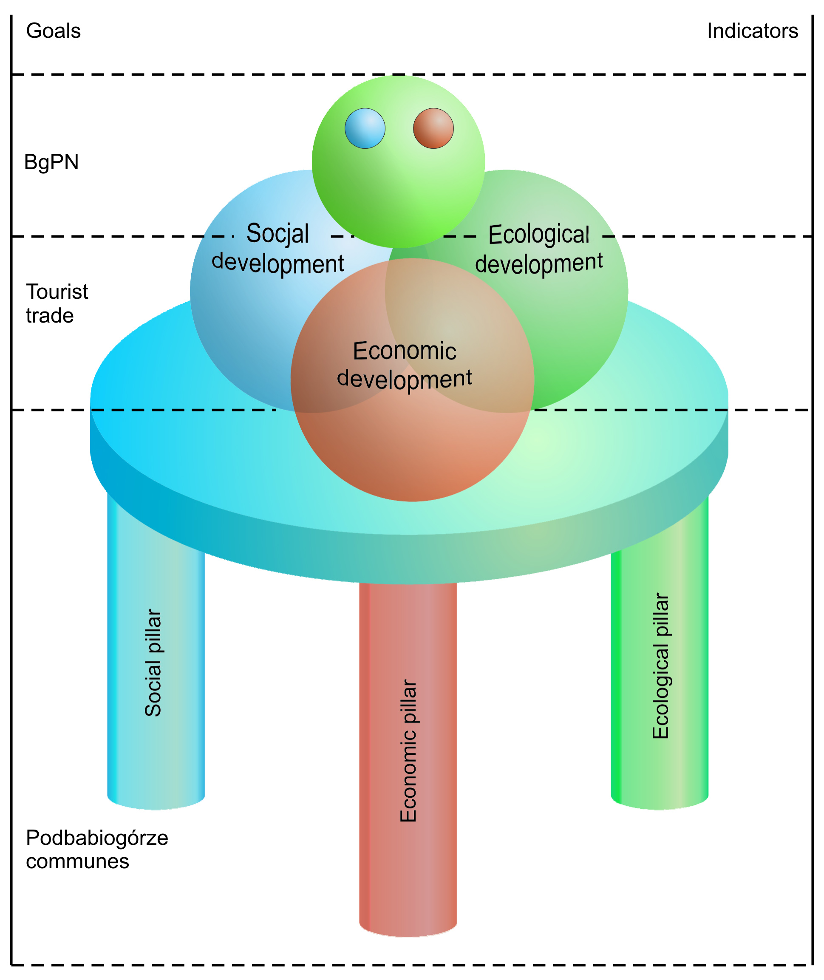
Picture 2. Schema of rules for creating of indicators for the balanced development of tourism in Babia Góra National Park, communes and the tourist trade in Podbabiogórze.

Indicators of monitoring of the balanced development of tourism in the area of Babia Góra National Park were developed after taking into account three basic documents:

1.Gebhard K., Meyer M., Roth St. (2007): Criteria for Sustainable Tourism for the three Biosphere Reserves Aggtelek, Babia Góra and Śumava. Ecological Tourism in Europe. Bonn.
2.The Integrated Strategy of Development of Podbabiogórskie Rural Areas. Joint publication. (2005-2006).
3. The Study of Directions of the Tourist Development in Podbabiogórze with the projects programme and activities to undertake. Joint Publication.(2007).Sucha Beskidzka.

The Integrated Strategy of Development of Podbabiogórskie Rural Areas includes activities aiming at supporting the following directions of Podbabiogórze development:
- the development of inter-sector partnership in the rural areas as a factor increasing effectiveness of local pro-development activities.
- the development of the balanced tourism
- the development of micro, small and medium-sized enterprises, which follow traditions as well as use Podbabiogórze resources and belong to the sectors of ‘ regional chance’ in Małopolska province
- the development of human resources in rural areas of Podbabiogórze as a basis for increasing sub-regional competitiveness and improvement of living standards of local society
The Study of Directions of the Tourist Development in Podbabiogórze with the projects programme and activities to undertake. Joint Publication.(2007) Sucha Beskidzka.

- the development of brand-product – recreation, active and specialist tourism (8 principal goals)
- the development of brand- product – tourism in the rural areas ( 2 principal goals)
- innovative organization and management of Podbabiogórze tourism (3 principal goals)

It is suggested for BgNP, the communes and the tourist trade to use three groups of indicators for the balanced development. First, indicators directly concerning BgNP. Second, indicators monitoring the balanced development in Podbabiogórskie communes. Third, tourist trade indicators (picture 3).

Division of the balanced development indicators for legally protected areas, adjacent ones, and the tourist trade

Micro-indicators

Macro-indicators
Tourist trade indicators

Picture 3. General division of suggested indicators for the balanced development for BgNP with adjacent areas, and tourist trade
Micro-indicators for the balanced development of tourism in Babia Góra National Park.

In the three groups a dozen or so indicators monitoring particular areas of the balanced development have been proposed. Pictures 4, 6, 8.
Micro-indicators for the balanced development of tourism in BNP
Indicators for the balanced development of tourism in the public sphere (3)
Indicators for the balanced development of tourism in the economic sphere (3)
Indicators for the balanced development of tourism in the ecological sphere (3)

Picture 4. Division of indicators for the balanced development of tourism in BgNP
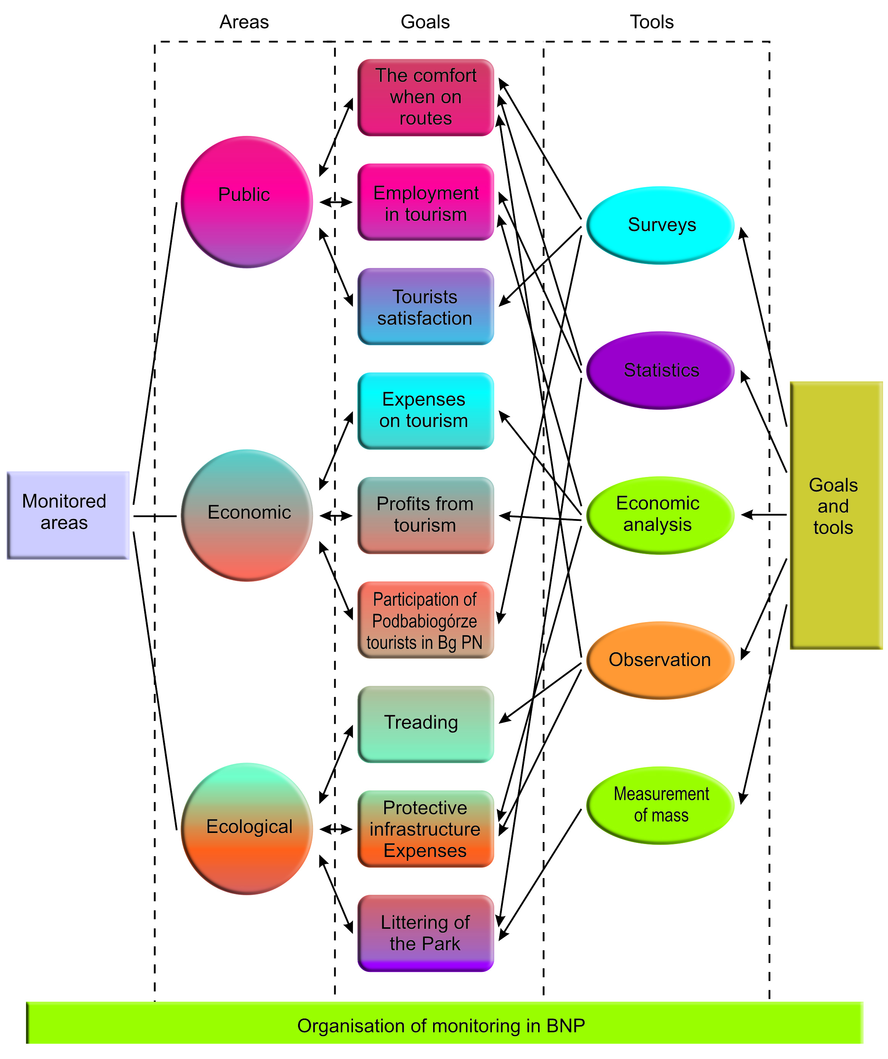
Picture 5. Organisation of monitoring of the balanced development of tourism in BgNP
Frames 1 – 25 show the ways to calculate individual indicators.

Frame 1. Indicator for the psycho-comfort on tourist routes (micro-indicator for the balanced development in the public sphere).
$$E=\left(\frac{C−B}{D}+1\right)\text{20}$$
When:
E – psycho-comfort capacity of a route
C – light day (in hours)
B – time on a route (in hours)
D – overall time for the rest (in hours)
20 – optimum no. of tourists in a group
Comments: Calculating the indicator for each month will let to manage tourist traffic in the park. It will guarantee the quality of tourist experiences; their positive perception of the nature.

Frame 2. Indicator for the employment in tourism, in the park (micro-indicator of the balanced development of tourism in the public sphere).

$$O_{c}=\frac{O_{t}}{O_{o}}\text{100}$$
When:
O_{c} – indicator for the employment in tourism in the park (%)
O_{t} – no. of park’s employees serving tourists
O_{o} – overall no. of park’s employees
Comments: Elements of the formula need to be discussed with management, to specify e.g. which posts considered as tourist service.

Frame 3. Indicator for tourist satisfaction with visits made to Babia Góra National Park (micro-indicator for the balanced development of tourism in the social sphere).

$$K_{z}=\frac{\left(\frac{Z_{u}+Z_{p}+Z_{i}}{3}\right)}{O_{b}}\text{100}$$
When :
K_{z} - indicator of tourist satisfaction with the visits in BbPN
Z_{u-} no. of tourists satisfied with the infrastructure of BgPN
Z_{p}- no. of tourists satisfied with guide-service in BgPN
Z_{j}- no. of tourist satisfied with information in BgPN
O_{b}- no. of respondents
Comments: The indicator of tourist satisfaction with the visits made to BgNP will be worked out on the basis of a survey. Research will concern tourist satisfaction with the qualities, attractions and tourist services in Podbabiogórze communes. The survey has already been started and the results shall be collected and worked out every year.
Frame 4. Indicator for annual expenses on tourism in the park (micro-indicator for the balanced development of tourism in the economic sphere).

$$W_{a}=\frac{W_{t}}{W_{o}}\text{100}$$
When:
W_{a} – indicator for expenses on tourism (%)
W_{t} – annual expenses on tourism from park’s bugged (zł or EU)
W_{o} – annual park’s expenses (zł or EU)
Comments: Elements of the formula need to be discussed with management e.g. which actually are tourism expenses.

Frame 5. Indicator for the annual income from tourism, for park’s bugged (micro-indicator for the balanced development of tourism in the economic sphere).

$$P_{a}=\frac{P_{t}}{P_{o}}\text{100}$$
When:
P_{a} – indicator for the income from tourism, for park’s bugged (%)
P_{t} – annual income from tourism , for park’s bugged (zł or EU)
P_{o} – annual park’s income (zł or EU)

Comments: Elements of the formula need to be discussed with management e.g. which income is actually from tourism.

Frame 6. Indicator for participation of tourists in visiting BgPN ( micro-indicator for the balanced development of tourism in the economic sphere)

$$T_{o}=\frac{T_{P}}{T_{\text{bgp}}}\text{100}$$
When:
T_{o} - indicator for the participation of tourists in visiting BgPN.
T_{p} – no. of tourists visiting BgPN and using accommodation facilities in Podbabiogórze area (per year)
T_{bgp} – no. of tourists visiting BgPN
Comments: The indicator shows what percentage of the tourist population using accommodation facilities in Podbabiogórze area visit BgPn ( per year).

Frame 7. Index for the park area trodden by tourists (micro-indicator for the balanced development of tourism in the ecological sphere).

$$L_{p}=\frac{L_{w}}{L_{o}}\text{100}$$
When:
L_{p} – indicator for the trodden area of the park
L_{w} – area of the park trodden by tourists (in ha)
L_{o} – overall area of tourist routes in the park (in ha)
Comments: Trodden areas maybe specified in many ways. The simplest is to measure physically, but satellite pictures may be used, as well. Just like other indicators, this one should not be looked at separately, but e.g. with tourism investments (the point of monitoring).

Frame 8. Indicator for the cost of park’s protective infrastructure in tourism (micro-indicator for the balanced development of tourism in the ecological sphere)

$$I_{\text{to}}=\frac{I}{W_{{}_{t}}}\text{100}$$
When:
I_{to} – indicator for the cost of park’s protective infrastructure
I – annual expenses on protective infrastructure in the park (zł or EU)
W_{t} – annual expenses on tourism from the parks bugged (zł or EU)
Comments: Elements of the formula need to be discussed with management e.g. which action actually is a part of the protective infrastructure of the park.

Frame 9. The indicator for litter level in the Park (micro- indicator for the balanced development of tourism in the ecological sphere)

$$\text{Wz}=\frac{M_{s}}{L_{\text{tr}}}$$

When:
Wz – indicator of litter level in the Park
M_{s} - mass of litter disposed from the Park within a year ( in kg)
L_{tr} – no. of tourists visiting the Park within a year
Comments: The indicator describes the mass of litter per one tourist. To some degree, it reflects ecological awareness of tourists visiting the Park.

Macro-indicators for the balanced development of tourism in Podbabiogórskie communes.

Macro-indicators for the balanced development of tourism in communes
Indicators for the balanced development of tourism in the public sphere (2)
Indicators for the balanced development of tourism in the economic sphere (2)
Indicators for the balanced development of tourism in the ecological sphere (2)

Picture 6. Macro-indicators for the balanced development of tourism in Podbabiogórskie communes

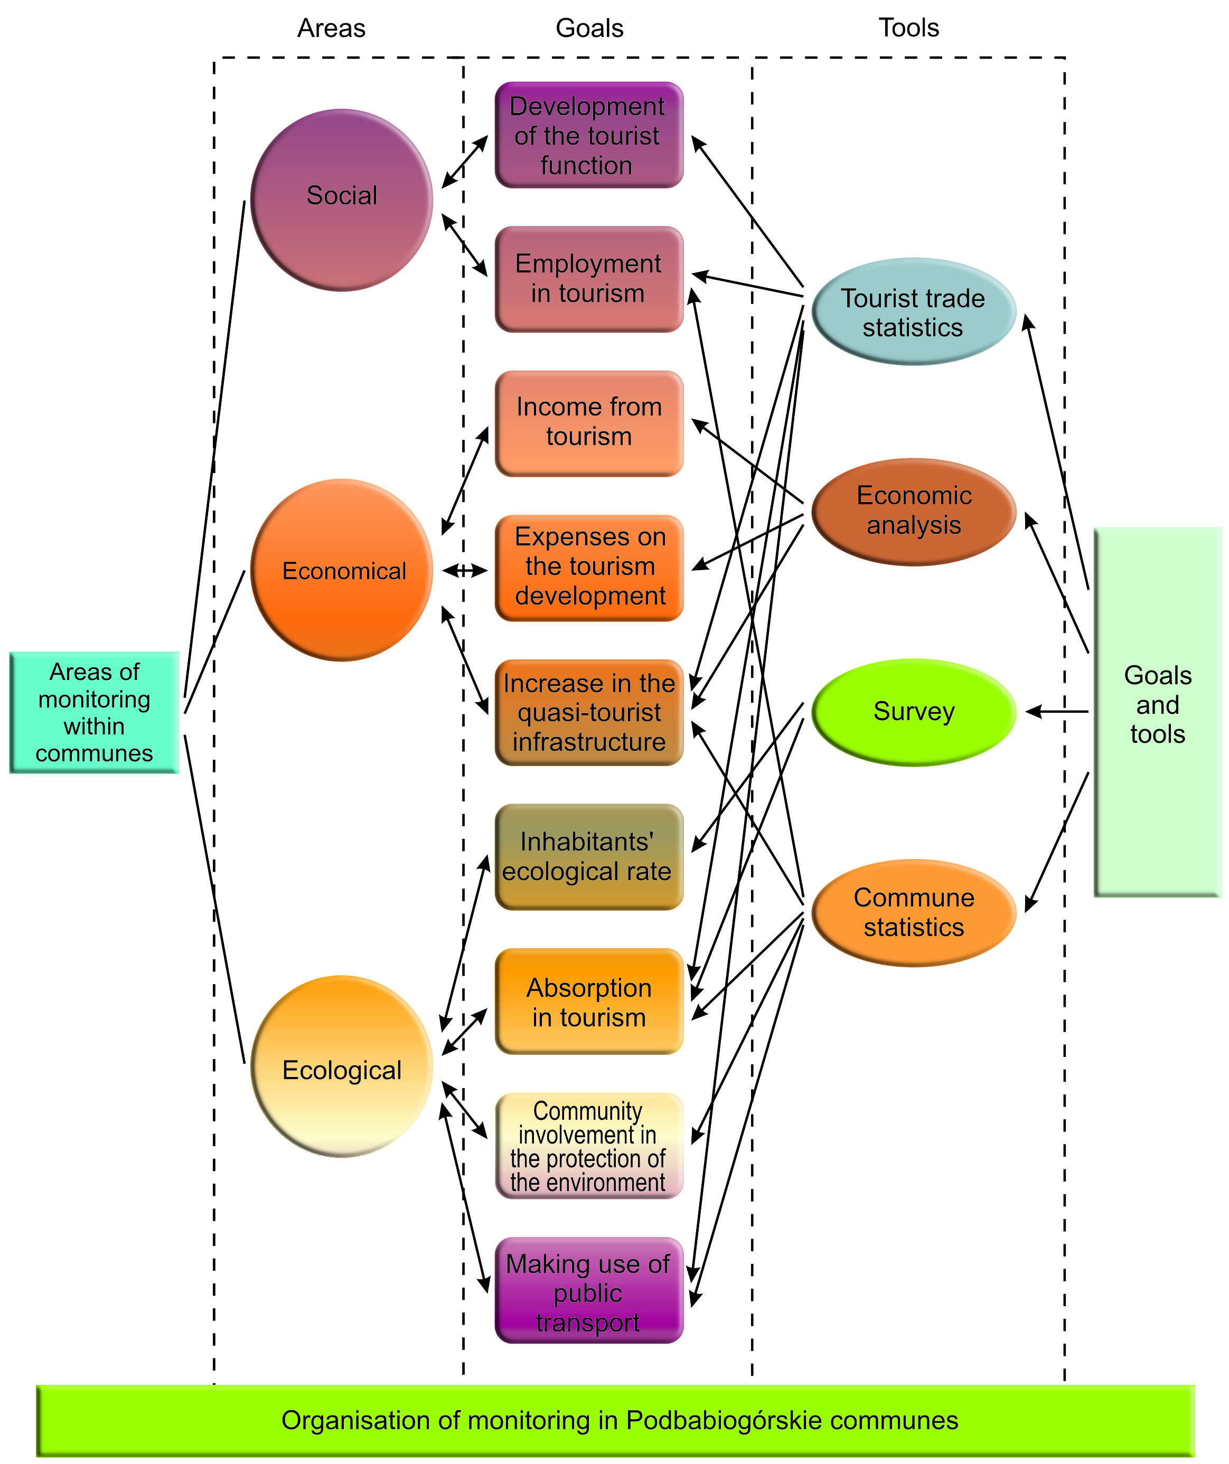
Picture 7. Monitoring of the balanced development of tourism in Podbabiogórskie communes

Frame 10. Development of tourist function in the commune (macro-indicator for the balanced development of tourism in the public sphere)

$$T_{(\text{ft})}=\frac{M_{n}}{L_{{}_{m}}}\text{100}$$
When:
T_{(ft)} – development of tourist function in the commune
M_{n} – no. of tourist accommodation
L_{m} – no. of the locals
Comments: Indicator for tourist function of a town, called Baretie and Defert indicator, has been used in tourism for years. It show how developed the tourist function is. For instance, indicator 100 – 500 means well developed tourism. All indicators shall not be analysed separately.

Frame 11. Indicator for employment in the tourist trade within the commune (macro-indicator for the balanced development of tourism in the public sphere)

$$Z=\frac{Z_{t}}{Z_{o}}\text{100}$$
When:
Z – indicator for employment in tourism
Z_{t} – no. of people within the commune employed in tourism
Z_{o} – no. of people employed within the commune

Another version:

$$Z=\frac{Z_{t}+0,5Z_{t1}+0,\text{25}Z_{t2}}{Z_{o}}$$
When:
Z_{t}1 – no. of people indirectly employed in tourism; professions with 50% of income from tourism
Z_{t}2 - no. of people indirectly employed in tourism; professions with 25% of income from tourism
Comments: Elements of the formula may remain, and the professions should be specified. The formula may be changed, too, when indirect tourism employment is considered. The list of professions may be provided.

Frame 12. Indicator for income from the tourist trade within the commune (macro-indicator for the balanced development of tourism in the economic sphere).

$$D=\frac{D_{t}}{D_{o}}\text{100}$$
When:
D – indicator for income from the tourist trade within the commune
D_{t} – commune’s income from the tourist trade (zł or EU)
D_{o} – commune’s overall income (zł or EU)
Comments: This formula can be extended, too, by adding mentioned earlier elements.

Frame 13. Indicator for expenses (from the bugged and EU subventions) on tourism in the commune (macro-indicator for the balanced development of tourism in the economic sphere)

$$W_{\text{tg}}=\frac{S_{g_{t}}+S_{\text{ut}}}{S_{g}+S_{u}}\text{100}$$
When:
W_{tg} – Indicator for tourism development expenses within the commune
S_{gt} – expenses form commune’s bugged on the development of tourism (zł or EU)
S_{ut} – money received from the EU and spent on tourism (zł or EU)
S_{g} – commune’s expenses (zł or EU)
S_{u} – the amount of money from the EU (zł or EU)
Comments: This indicator includes commune’s expenses on tourism, only. An additional indicator may be created to illustrate expenses on the protection of the environment (concerning e.g. sewage system, water supply system, waste, CO2 emission). Probably every commune in Poland uses such indicators because they must be used in order for the commune to receive EU subventions.

Frame 14. Indicator for the increase in capacity of quasi-tourist infrastructure in the commune ( macro- indicator for the balanced development of tourism in the economic sphere )

$$R_{i_{t}}=\frac{I_{\text{pr}}}{I_{o}}\text{100}$$

When:
R_{it} – indicator for the increase in capacity of quasi-tourist infrastructure in the commune
I_{pr} – capacity of quasi- tourist infrastructure created in the given year in the commune (no. of people)
I_{o} – capacity of general tourist infrastructure in the commune (no. of people)
Comments: The indicator informs us about the increase in the quasi-tourist infrastructure in the area of Podbabiogórze

Frame 15. Inhabitants ecological rate (ecological footprint) in the commune (macro-indicator for the balanced development of tourism in the ecological sphere)

The ecological rate will be defined in conventional hectares. Surveys will be carried out, its results processed through proper computer program.
Four criteria to be considered:
home (how big, how many people living, types of buildings, types of heating, energy-saving equipment)
food products (processed food, imported food, how often meat, dairy, fish, and eggs consumed, how much food consumed)
goods (rubbish sorted)
communication (the use of public transport, fuel used up, average no. of km when public transport, motor bike, or a car used)
Comments: The indicator easy to carry into effect. It informs how many conventional hectares the commune’s inhabitants actually need. All sorts of action may follow e.g. keeping the locals informed and aware of the overall picture of situation within the four criteria. The indicator has been calculated for few communes.

Frame 16. Maximum tourism absorption in the commune (macro-indicator for the balanced development of tourism in the ecological sphere).

$$C_{\text{max}}=\frac{\text{100}ϖΠ}{\underset{}{\overset{}{}}\sum{}d_{i}S_{i}}$$
When:
C_{max} – maximum absorption (no. of tourists)
II – the area available for tourists (in Ha)
w – environment resistance ratio
d_{i} – free tourists movement on 1ha ratio
S_{i} – structure of tourist movement – numbers illustrating in percentage the variety of movement (S₁, S₂,…S_{n})
Comments: The indicator defines the optimum no. of tourists active in the commune area at the same time. It includes the time for recreation e.g. the percentage of tourist staying for 7-14 days, those who stay for weekends etc. This indicator has been calculated few years ago for Zawoja, the result was 4 975 – 5 057 tourists. We have been working recently to extend the indicator by adding the psychological absorption elements (comfort of recreation when tourist vs. tourist, and tourist vs. the locals); by adding the physical absorption, too (tourist and commune infrastructure efficiency).

Frame 17. Indicator for local community involvement in the protection of the environment (macro-indicator for the balanced development of tourism in the ecological sphere).

$O_{s}=\frac{O_{\text{och}}}{L_{m}}\text{100}$;

When:
O_{s} – indicator for local community involvement in the protection of the environment;
O_{och} – no. of members of different non-governmental organizations in the commune dealing with the protection of the environment , ecology, balanced development.;
L_{m} – no. people in the commune
Comments: The indicator determines the degree of involvement of Podbabiogórze community in the activities for the benefit of protection of the environment.

Frame 18. Indicator for using public transport by tourists (macro-indicator for the balanced development of tourism in the ecological sphere).

$$P_{s}=\frac{K_{p}}{L_{\text{to}}}\text{100}$$

When:
P_{s} – indicator for using public transport by tourists;
K_{p} – no. of tourists who came to accommodation places in the commune by means of public transport;
L_{to} – general no. of tourists (per year) using accommodation facilities located in the commune
Comments: The indicator shall show the degree of using public transport by tourists.

Indicators for the balanced development for the tourist trade of Pobabiogórze

Indicators for tourist trade
Indicators for the balanced development of tourist trade in the public sphere (2)
Indicators for the balanced development of tourist trade in the economic sphere (2)
Indicators for the balanced development of tourist trade in the ecological sphere (2)

Picture 8. Indicators for the balanced development of tourist trade in Podbabiogórze

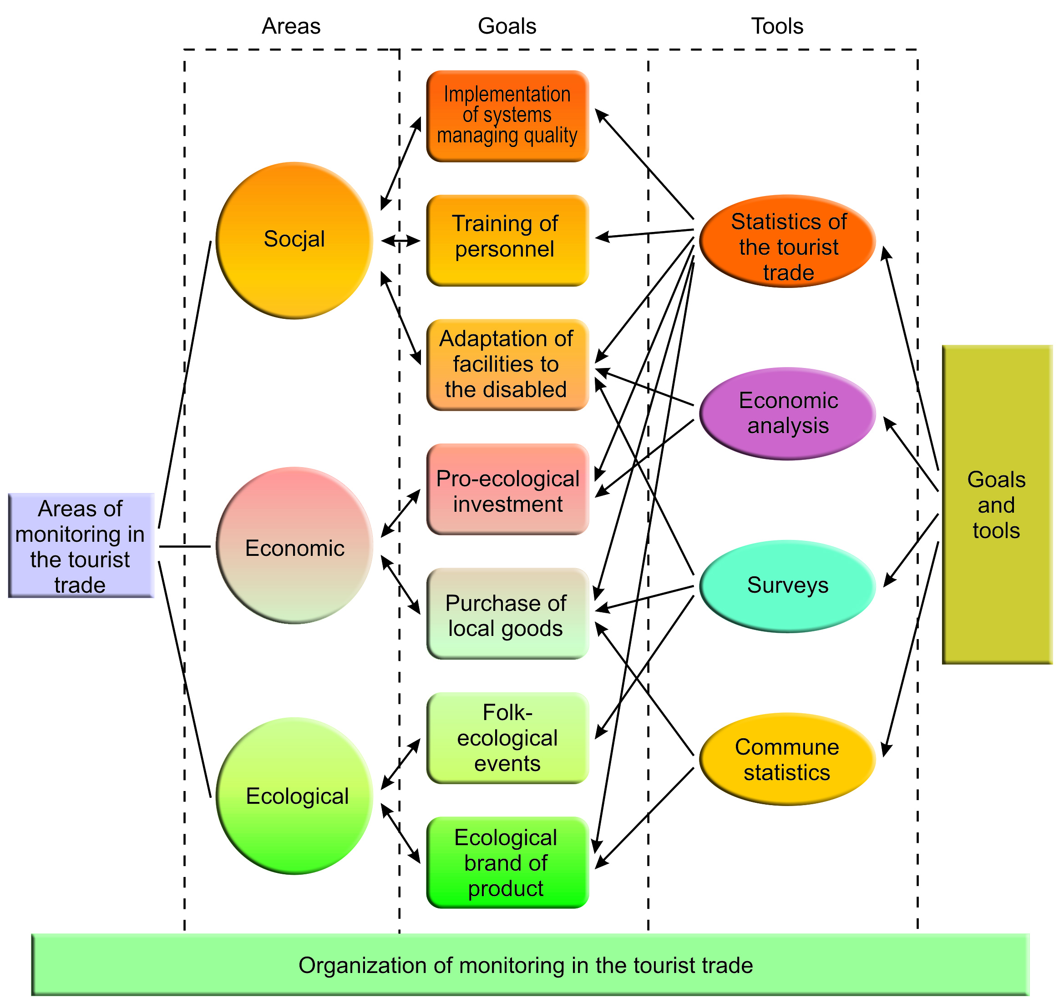
Picture 9. Organization of monitoring in the tourist trade.

Frame 19. Indicator for introducing the quality management systems in tourist businesses (indicator of the balanced development of tourism in the public sphere).

$$\text{IE}=\frac{L_{o}}{L_{f}}\text{100}$$
When:
IE – Indicator for introducing the environment quality management systems
L_{o} – no. of tourist businesses in Podbabiogórze with ISO 14 000, EMAS or another
L_{f} - no. of tourist businesses in Podbabiogórze
Comments: The indicator shows how actively the businesses are involved in pro-ecology projects.

Frame 20. Indicator for the training and education of employees within the balanced development of the tourist trade (indicator for the balanced development of tourism in the public sphere)

$$A_{z}=\frac{A_{\text{pc}}+A_{t}}{Z_{t}}\text{100}$$
When:
A_{z} - indicator for the training and education of employees within the balanced development of the tourist trade (accommodation, gastronomy, entertainment)
A_{pc} – no. of people, in the tourist trade of Podbabiogórze, with certificates, diplomas etc. after professional training, courses etc. within the balanced development (documents received within last 3 years)
A_{t} – no. of people, in the tourist trade of Podbabiogórze, trained in a particular year within the balanced development
Z_{t} – no. of people employed in the Podbabiogórze tourist trade
Comments: The indicator shows the improvement of the tourist trade within the balanced development.

Frame 21.Indicator for adaptation of accommodation facilities to the disabled and old people .

$$N_{\text{on}}=\frac{L_{\text{ON}}}{L_{n}}\text{100}$$

When:
N_{on} – indicator for adaptation of accommodation facilities to the disabled and old people;
L_{ON} - no. of tourist accommodation facilities in the communes of Podbabiogórze adapted to the disabled;
L_{n} – no. of tourist accommodation facilities in the communes of Podbabigórze
Comments: The indicator informs us about activities of the tourist trade aiming at adapting accommodation facilities to the disabled and old people.

Frame 22. Indicator for expenses on pro-ecology investments in tourist businesses in Podbabiogórze (indicator of the balanced development of tourism in the economic sphere).

$$N_{e}=\frac{W_{t_{p}}}{W_{t_{o}}}\text{100}$$
When:
N_{e} –indicator for expenses on pro-ecology investments in tourist businesses in Podbabiogórze
W_{tp} – annual pro-ecology expenses in tourist businesses in Podbabiogórze (zł or EU)
W_{to} – annual expenses in tourist businesses in Podbabiogórze (zł or EU)

Comments: Because the tourist trade consists of a variety of businesses, the list of pro-ecology investments would be useful.

Frame 23. Indicator for the purchase of local goods (indicator for the balanced development of tourism in the economic sphere).

$$Z_{m}=\frac{Z_{l}}{Z_{o}}\text{100}$$
When:
Z_{m} – indicator for the purchase of local goods (zł or EU)
Z_{l} – annual expenses on the purchase of local goods by tourist businesses (zł or EU)
Z_{o} - annual expenses on the purchase of goods by tourist businesses (zł or EU)
Comments: The indicator does not define kinds of goods e.g. groceries or building materials. If necessary all the elements can be specified. All the indicators before used should be consulted with the public to agree on the way of calculating.

Frame 24. Indicator of pro-ecology, cultural, or folk tourist events organized by tourist businesses (indicator for the balanced development of tourism in the ecological sphere).

$$I_{e_{t}}=\frac{I_{e}}{I_{t}}\text{100}$$
When:
I_{et} - indicator of pro-ecology, cultural, or folk tourist events organized by tourist businesses
I_{e} – no. of pro-ecology, cultural, or folk tourist events organized in a particular year
I_{t} – no. of tourist events organized by Podbabiogórskie tourist businesses in a particular year

Frame 25. Brand Indicator – Podbabiogórski Ecological Tourist Product (indicator of the balanced development of tourism in the ecological sphere).

$$M_{e}=\frac{M_{p}}{L_{f}}\text{100}$$
When:
M_{e} - Brand Indicator – Podbabiogórski Ecological Tourist Product
M_{p} – no. of the PETP certificates given to tourist businesses in Podbabiogórze
O_{c} – no. of the tourist trade businesses in Podbabiogórze
Comments: A board needs to be created and criteria of awarding businesses with the brand need to be specified.

Should the indicator not work, it may be substituted with another one, investigating particular issue. Exchanging indicators will depend on current needs e.g. when one source of information stops to exist, another area for monitoring shall be chosen etc. Indicators have been chosen in such a way that to analyse one of them helps to analyse a further one.

  - The organization

Monitoring requires constant data gathering, its analysis, drawing conclusions etc. (picture 10). That is why the proper organization infrastructure, and preparing the rules for its action is crucial. The best solution would be creating Podbabiogórska Tourist Organization (PTO), with tourism monitoring post. Expert in monitoring would co-operate with PTO. In stages of gathering and processing needed information students of Tourism and Ecology College in Sucha Beskidzka (WSTiE) could work. It would be the most educating, meaningful, and practical work experience for them.

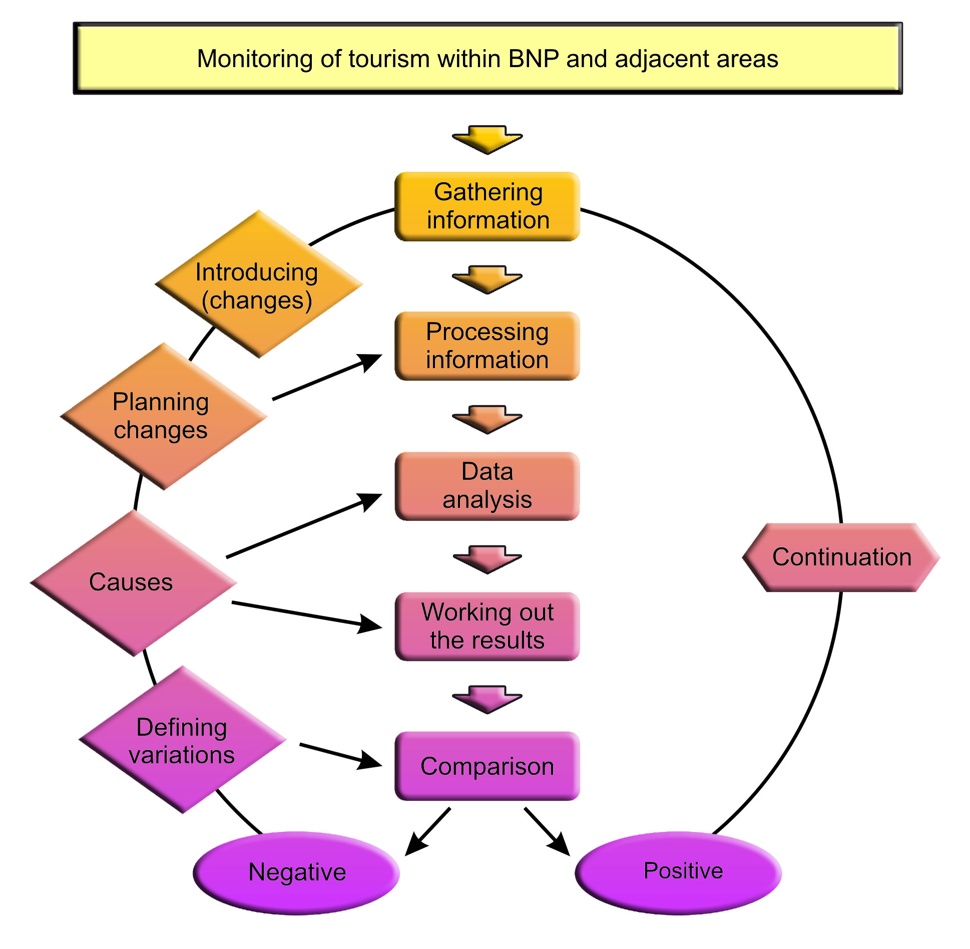
Picture 10. Assumptions of monitoring of the balanced development of tourism within BgNP & adjacent areas.

Main tasks connected with tourism monitoring in BgNP and adjacent communes are:
- gathering information
- outdoor research works
- gathering and filing data
- processing information
- data analysis and drawing conclusions
- writing reports
- working out directions of changes.

An expert in monitoring of the balanced development of tourism should receive proper instructions. He needs to be informed e.g. when, how, in what shape, and who is to receive monitoring results.

- Realization of monitoring

Well created monitoring of tourism in BgNP, communes and tourist enterprises guarantees receiving proper information in the right time. To illustrate monitoring the picture 11 presents all its stages and tasks.

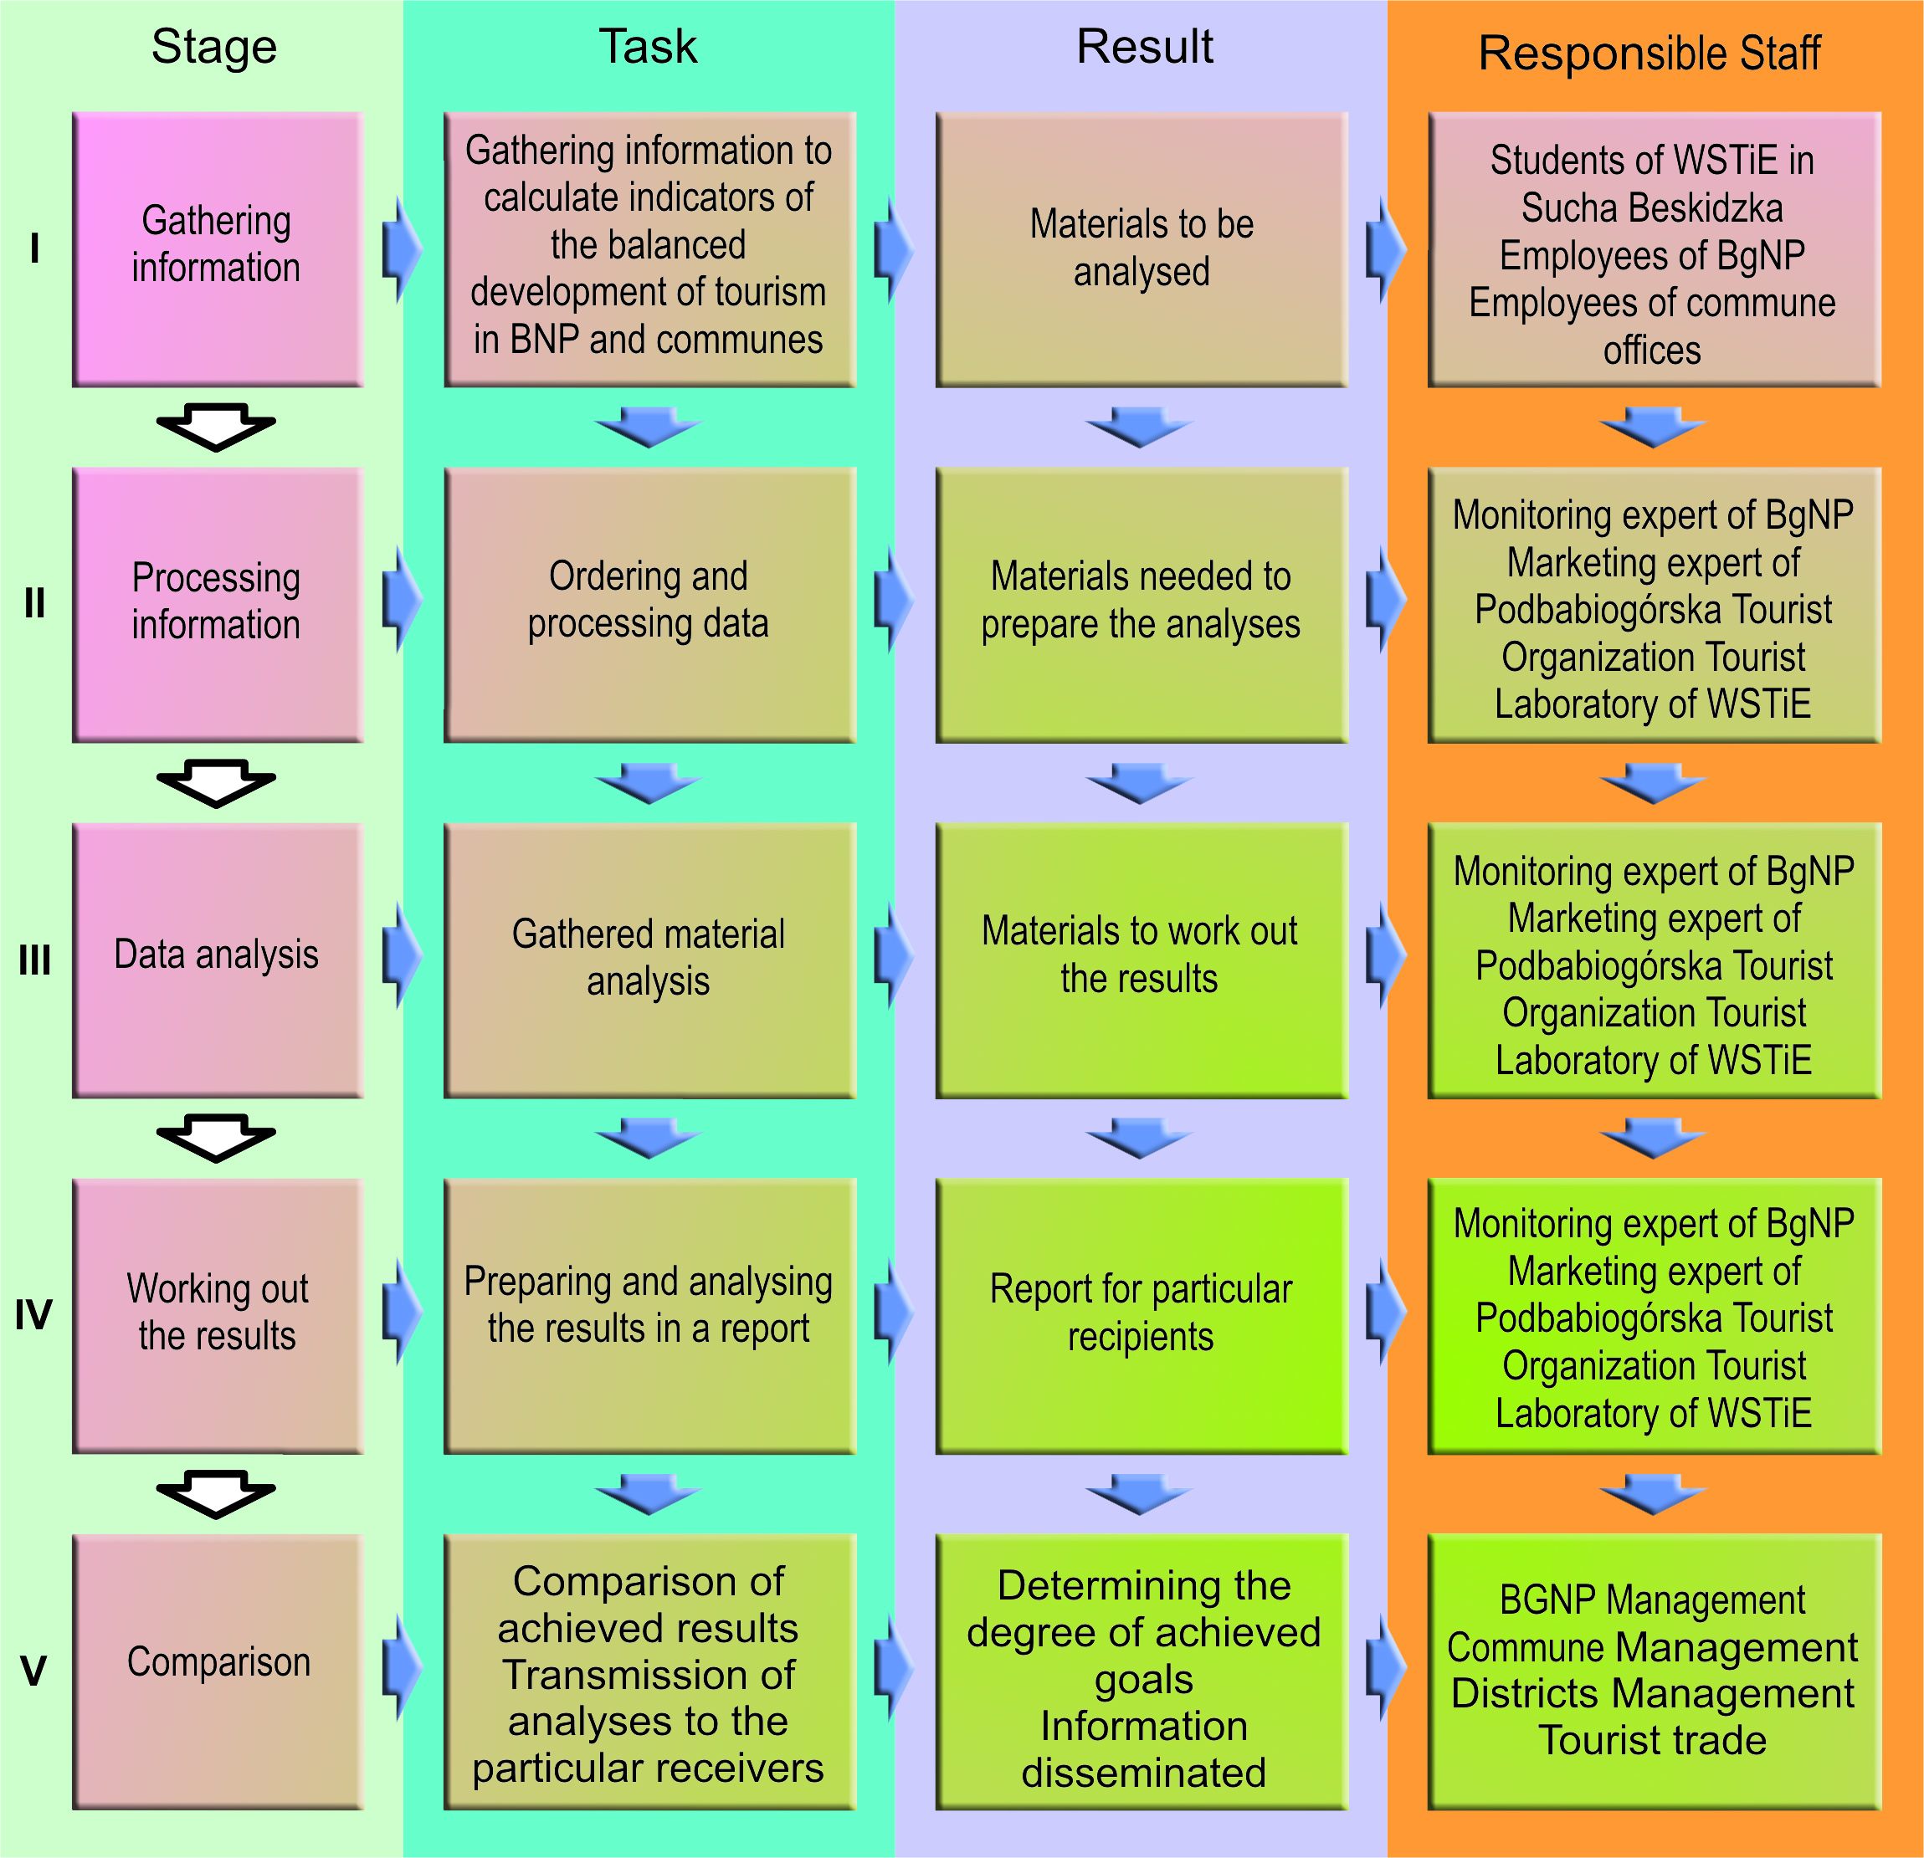
Picture 11. The rules of monitoring of the balanced development of tourism in BgNP and Podbabiogórskie communes.

Monitoring tourism in BgNP and the communes should be carried out in two ways:
- currently
- in a long term.

Current data analysis makes quick recognition of difficulties easier. It lets the changes to be introduced quickly.
Long term monitoring in tourism allows to observe dynamic of realizing planned tasks.

Evaluation procedures are an important part of the process of monitoring of the balanced tourism in Podbaqbiogórze. So far, there has not been one definition of evaluation; in the literature on the topic we can encounter many different definitions. For the monitoring of the balanced tourism three stages of evaluation procedures, have been suggested:

-ex- ante evaluation – made before the implementation of: The Integrated Strategy of Development of Podbabiogórskie Rural Areas and The Study of Directions of Tourist Development in Podbabiogórze with the project programme and activities to undertake.

- mid-term evaluation – carried out halfway through implementing of the above mentioned studies

- ex-post evaluation – carried out after the implementation.

The correction of indicators will be made in each of the three periods as a result of evaluation. Should a certain indicator not work (because of different reasons) it will be replaced with a new one. The rule of continuous development of indicators and introducing additional ones has been assumed. Implementing of new indicators depends on several factors:

- the potential of members of the monitoring team
- financial possibilities of the team
- needs resulting from the monitoring of new aims or areas
- acceptance of subjects implementing suitable documents

5. Conclusion

Proper use of monitoring of the balanced development of tourism in Babiogórski national park and Podbabiogórskie communes will allow the park’s management to making changes in programmes of development in particular areas. It will serve district management and tourist businesses, too. Systematic gathering of information makes e.g. annual assessment of effectiveness, of particular projects easier. It makes the assessment of the general development of tourism within the area easier.

It is worth to mention, that the assessment of realization should be performed by the same team, which prepared the programme of the tourism development. These were the people who prepared strategies, defined goals, and priorities.

